**Capstone Project Review-1**

**CHATBOT TO RESPOND TO MINING ACT QUERIES**

|  |  |
| --- | --- |
| **Roll Number** | **Student Name** |
| **20211CSE0610** | **Mohammed Azeem A** |
| **20211CSE0615** | **Ashfaq Ur Rahman H N** |
| **20211CSE0619** | **Sagar H N** |

**Under the Supervision of:**

**DR. MOHAMMED MUJEER ULLA**,

**Associate Professor, School of Computer Science and Engineering,**

**Presidency University**

**Batch Number:** 127  
**Program:** B.Tech in CSE  
**HoD:** Dr. Asif Mohammed H B  
**Program Project Coordinator:** Dr. Amarnath  
**School Project Coordinators:** Dr. Sampath A K / Dr. Abdul Khadar A / Mr. Md Ziaur Rahman

**Introduction**

A chatbot is a computer program that uses **Artificial Intelligence (AI)** and **Natural Language Processing (NLP)** to understand customer questions and automate responses, imitating human conversation. The mining industry is governed by various **Acts, Rules, and Regulations, DGMS Circulars, and CoI Proceedings**, including:

* The Coal Mines Act, 1952
* Indian Explosives Act, 1884
* Colliery Control Order, 2000
* Colliery Control Rules, 2004
* The Coal Mines Regulations, 2017
* The Payment of Wages (Mines) Rules, 1956

Additionally, land-related laws such as **CBA, LA, and RandR** can be incorporated to develop a **Robust Management Information System**. Hence, a **24/7 chatbot** is proposed to assist stakeholders and customers with queries related to these laws.

**Literature Review**

**1. AI and NLP in Chatbots**

Research shows that **AI-driven chatbots** leverage NLP techniques like **intent recognition, named entity recognition (NER), and context-aware responses**, reducing human intervention in information retrieval.

**2. Chatbots in Regulatory Compliance**

Studies highlight chatbot applications in **healthcare, finance, and legal sectors** for interpreting complex laws and ensuring compliance. Similarly, mining regulations require real-time access to legal provisions.

**3. Mining Industry and Regulatory Challenges**

Mining regulations cover **safety, wages, land acquisition, and environmental policies**. Traditional methods for accessing legal information are time-consuming. AI-powered chatbots can serve as **24/7 query resolution systems** for quick access to legal updates.

**Existing Methods & Drawbacks**

|  |  |
| --- | --- |
| **Existing Method** | **Drawbacks** |
| Manual Documentation & Legal Consultation | Time-consuming, prone to human error, and lacks 24/7 availability. |
| Static FAQ-Based Systems | Limited to predefined questions, cannot handle complex queries. |
| Keyword-Based Search Engines | Ignores context, provides overwhelming or irrelevant results. |
| Rule-Based Chatbots | Rigid responses, unable to adapt or learn from user input. |

**Proposed Method**

The proposed solution is an **AI-powered chatbot** that utilizes **Natural Language Processing (NLP) and Machine Learning (ML)** to understand and respond to queries related to **mining regulations, Acts, Rules, and DGMS Circulars**. The chatbot will:

* Analyze user input and extract relevant legal information.
* Provide **accurate, context-aware answers** in real-time.
* Be **accessible 24/7** for stakeholders and customers.

**Objectives**

* Develop an **AI-driven chatbot** for legal mining queries.
* Implement **NLP models** for query processing and intelligent responses.
* Ensure **fast and accurate legal information retrieval**.
* Enhance **user experience** with **natural language conversations**.

**Methodology & Modules**

|  |  |
| --- | --- |
| **Module** | **Function** |
| **User Interface (UI)** | Web/Mobile interface for user interaction. |
| **User Query Processing** | Tokenization, intent recognition, and NLP-based query understanding. |
| **NLP & Machine Learning Engine** | AI models for legal text processing and semantic search. |
| **Query Classification** | Categorizes queries into Acts, Rules, Circulars, etc. |
| **Knowledge Base & Database** | Stores legal documents, DGMS Circulars, and regulations. |
| **Response Generation** | AI formulates accurate and context-aware replies. |
| **Feedback & Continuous Learning** | Improves chatbot responses based on user interactions. |

**Architecture**

1. **User submits query** → 2. **NLP processing** → 3. **Query classification** → 4. **Legal database search** → 5. **AI-based response generation** → 6. **User receives answer**

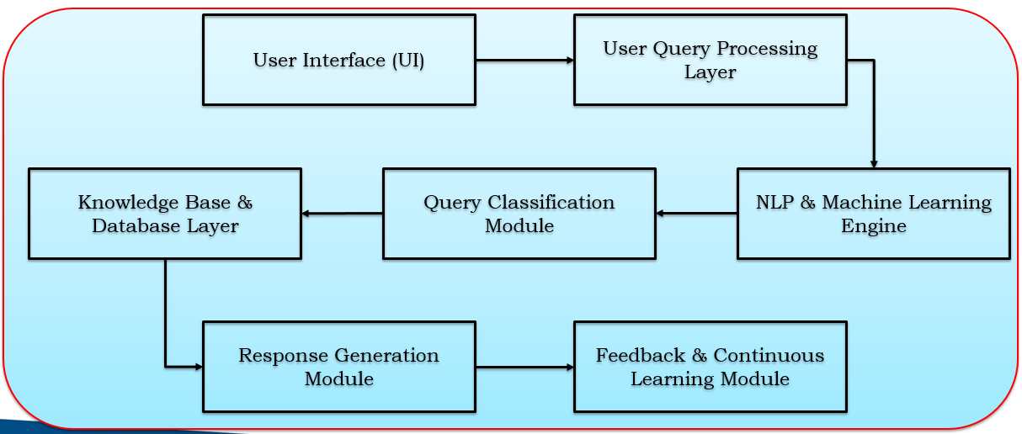

**Tools and Components**

|  |  |
| --- | --- |
| **Category** | **Tool/Component** |
| **Programming Language** | Python |
| **NLP Libraries** | TensorFlow, PyTorch, spaCy, NLTK, LangChain, Rasa |
| **Database Management** | MySQL, PostgreSQL, MongoDB, Elasticsearch |
| **Frontend Development** | React, HTML, CSS, JavaScript |
| **Backend Development** | Flask, FastAPI, Django |
| **Cloud & Deployment** | AWS, Google Cloud, Azure, Docker, Kubernetes |

**Expected Outcomes**

**Expected Outcomes of the AI-Driven Chatbot for Mining Regulations**

1. **24/7 Automated Legal Assistance**
   * The chatbot will provide **instant responses** to queries regarding **mining laws, regulations, DGMS Circulars, and CoI Proceedings**, reducing dependency on human experts.
2. **Efficient Information Retrieval**
   * Users will be able to **quickly access relevant legal provisions** without manually searching through large legal documents.
3. **Improved Compliance & Decision-Making**
   * Mining stakeholders can **ensure regulatory compliance** by getting **accurate, up-to-date legal information**, reducing legal risks.
4. **Natural Language Understanding (NLP-Based Queries)**
   * The chatbot will **interpret and answer questions in natural language**, making legal information **more accessible** to non-experts.
5. **Scalability & Continuous Learning**
   * The system will **learn from user interactions** to improve responses and **adapt to new legal updates**.
6. **Reduced Workload for Legal Experts**
   * Automating **frequently asked queries** allows legal professionals to focus on **complex cases** rather than routine questions.
7. **User-Friendly Interface**
   * A **web or mobile chatbot** will provide an **interactive, intuitive experience**, making it easy for stakeholders to get legal information.
8. **Robust Management Information System (MIS)**
   * The chatbot can be **integrated into company portals** to serve as a centralized **legal information hub**.

**Conclusion**

The AI-driven chatbot for mining regulations provides a **smart, efficient, and accessible** solution for retrieving legal information. By leveraging **NLP and AI**, it ensures **24/7 availability, quick responses, and improved compliance**, reducing reliance on legal experts and improving **decision-making in the mining industry**.

**GitHub Repository**

[GitHub Link](https://github.com/azeem-3/mining_act_chatbot)

**References (IEEE Format)**

1. S. Meshram, N. Naik, M. VR, T. More, and S. Kharche, "Conversational AI: Chatbots," 2021 International Conference on Intelligent Technologies (CONIT), Hubli, India, 2021, pp. 1-6, doi: 10.1109/CONIT51480.2021.9498508.
2. Chiara Valentina Misischia, Flora Poecze, Christine Strauss, "Chatbots in customer service: Their relevance and impact on service quality," *Procedia Computer Science*, Volume 201, 2022, Pages 421-428.

**Thank You!**